**ANALYSIS BY AGE & GENDER**

Average of all athletes by gender ,varies a little by gender but the median value is same for both Male & Female ,the value is ‘26’ for both Male & Female.Variation in average age   
& median age is because their are more number of males participants compared to females.

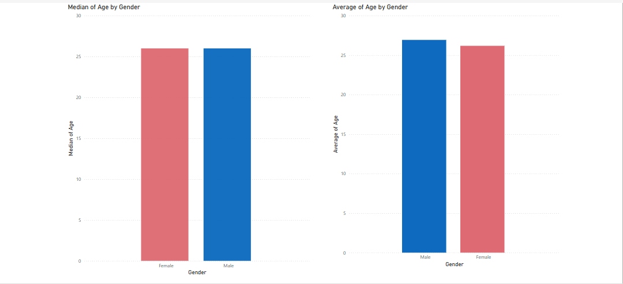

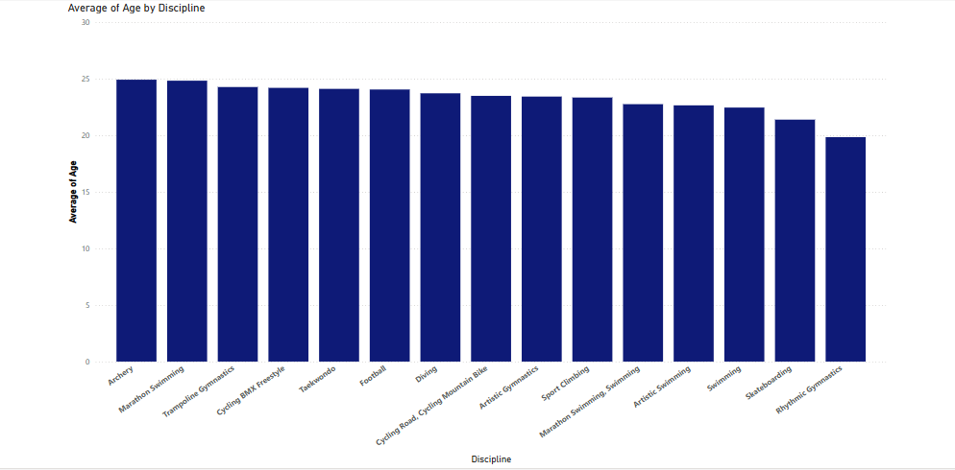

Disciplines which require a lower average age than 25. For sports aspirants from these disciplines , an early head start in their career increases their chances of winning.Games like “Rythmic gymnastics” show a value of 19.5 (even lower than 20) .

**ANALYSIS BY MEDALS WON :**

Participating Countries and their medal distribution.

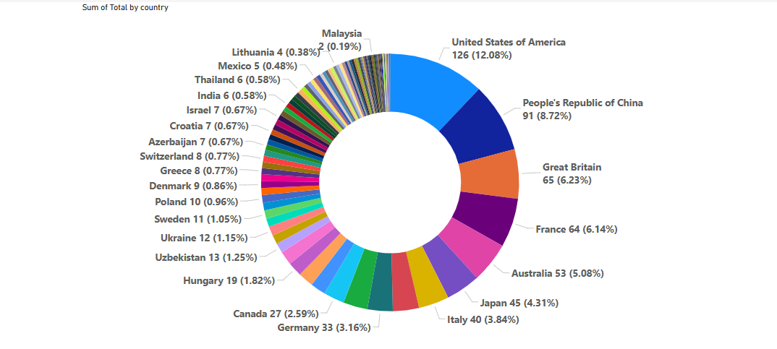

**Top 5 countries securing most Gold medals :**

